Installing Vagrant on Ubuntu

Follow the steps:

1. Open Firefox on Ubuntu(my version is 15.04) and go to

<https://www.vagrantup.com/downloads.html>

1. Take note of Linux or Debian 64 bit download, and copy the URL in clipboard

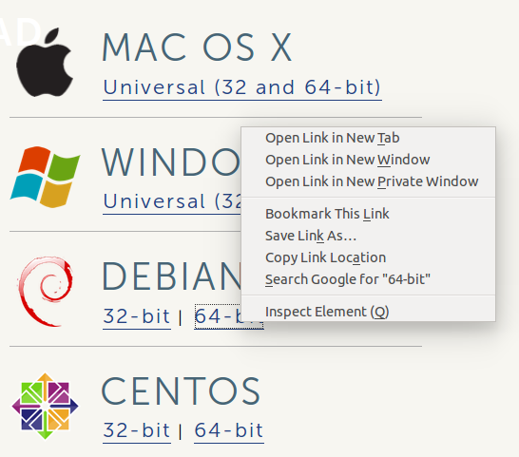

On command terminal

$ Cd desktop

Use link to download the vagrant installer:



1. Install the vagrant



1. If VM is not installed, download and install that using



1. Now, download the vagrant box for Ubuntu, it should be Ubuntu/trusty64



1. Initialize the box now



1. Run the vagrant



Troubleshoot:

In case *$ vagrant up* does not work, try sudo

$ sudo vagrant up

If that still fails, look if you have enough disk memory (disk space) available

If you have enough disk space available, then try uncommenting the following code from *vagrantfile* as following to enable UI mode of virtual Box:

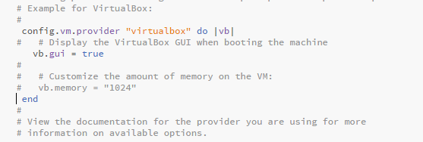

Now again try running

$ sudo vagrant up

Pay attention to virtual Box UI, does it throw some error message? If error message is related to *virtualization not enabled* then you might have to enable virtualization in your computer. If you are trying to install vagrant inside a virtual Box, then make note that nested virtualization is not yet supported in virtual Box as of the time of writing this note. Try using HyperV instead.

*Ref:* [*http://www.bogotobogo.com/DevOps/Vagrant/Creating_Virtual_Boxes_Using_Vagrant.php*](http://www.bogotobogo.com/DevOps/Vagrant/Creating_Virtual_Boxes_Using_Vagrant.php)

***Note***:

Important Commands:

* To stop vagrant instance:

$ sudo vagrant halt

* To destroy the vagrant instance:

$ sudo vagrant destroy

To shutdown and re-start the vagrant VM:

$ sudo vagrant reload

If you are installing vagrant on windows box, use powershell to run the command line and these will work (of course, don’t use *sudo*)

Steps to install multiple Vagrant Virtual boxes from one vagrantfile

Assuming, you are using powershell on windows:

1. Go to C:\programfiles\hashicorp\vagrant\bin folder
2. Edit vagrantfile as following:

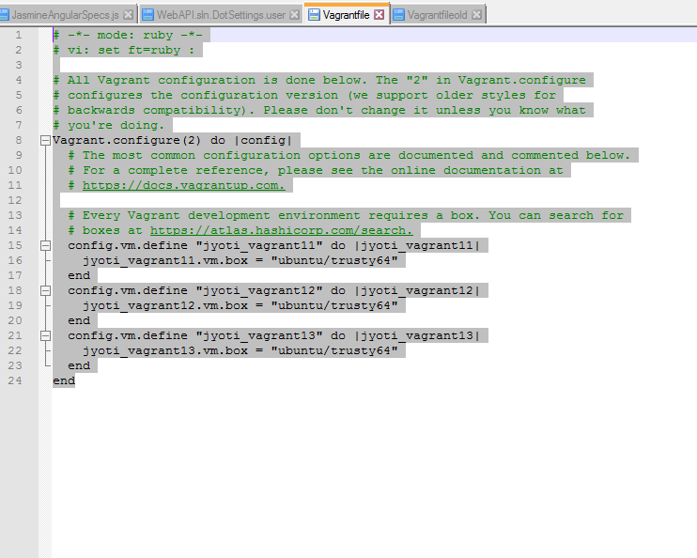

1. On powershell command prompt, run the following command:



It should create 3 different VMs on your computer

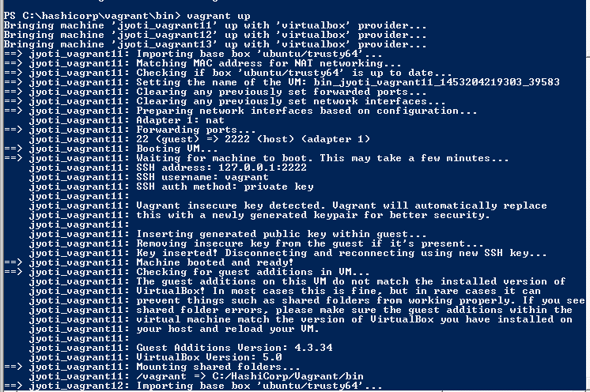

1. Open the Virtual box console, you should see the 3 new VMs running
2. Hit ‘Show’ on virtual box, and login to Vagrant box running Ubuntu.

Default userid/pwd is *vagrant/vagrant*

